RE Long Term Plan 2025/26
EYFS and KS1 and LKS2 are following the ‘To Know You More Clearly’ scheme of work
Years 5 and 6 are currently following the ‘Come and See’ scheme of work
Year Group | Autumn | Spring | Summer
Nursery  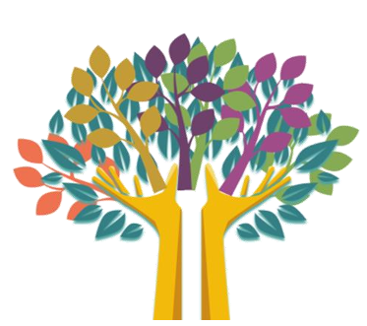 | Creation and Covenant  God created the world, God made me.  Prophecy and Promise  Mary’s Baby | Galilee to Jerusalem  Jesus was born for everyone  Desert to Garden  Jesus died on the cross. Jesus rose and we celebrate | To the Ends of the Earth  The Holy Spirit looks after us.  Dialogue and Encounter  Friends of Jesus  Other Faiths
Reception | Creation and Covenant  God created the world, God made me  Prophecy and Promise  Mary’s Baby | Galilee to Jerusalem  Jesus was born for everyone  Desert to Garden  Jesus died on the cross. Jesus rose and we celebrate | To the Ends of the Earth  The Holy Spirit looks after us.  Dialogue and Encounter  Friends of Jesus  Other Faiths
Year 1 | Creation and Covenant  That all that is, comes from God.  Prophecy and Promise  The Annunciation | Galilee to Jerusalem  The Presentation of Jesus  Desert to Garden  Lent is a special time for praying, fasting, and helping others as Jesus taught us to do.  Jesus died and rose again. | To the Ends of the Earth  The Ascension and Pentecost  The Holy Spirit looks after us.  Dialogue and Encounter  Friends of Jesus  Other Faiths
Year 2 | Creation and Covenant  The story of Noah  Prophecy and Promise  prophets and prophetesses communicate God’s message | Galilee to Jerusalem  The preaching of John the Baptist  Desert to Garden  Lent is a time of preparing our hearts and minds for Easter through  reconciliation and forgiveness | To the Ends of the Earth  The Holy Spirit looks after us.  Dialogue and Encounter  Other Faiths
Year 3 | Creation and Covenant  Genesis  Prophecy and Promise  Linking the fruits of Creation with the presentation of the gifts at Mass. | Galilee to Jerusalem  The Feast of the Epiphany  Desert to Garden  The ways in which Catholics are called to live Eucharist by following the example of Jesus. | To the Ends of the Earth  The Ascension  Dialogue and Encounter  Other Faiths
Year 4 | Creation and Covenant  The story of Abraham  Prophecy and Promise  Elijah  The meaning of prophecy | Galilee to Jerusalem  Jesus is the Messiah/Christ  Desert to Garden  St Matthew shows Jesus as the servant Messiah. The story of St. Peter in Holy Week | To the Ends of the Earth  The structure of the Church and why it is called ‘apostolic’.  Dialogue and Encounter  St Paul  Other Faiths
Year 5 | Ourselves  Domestic Church/  Family  Life Choices  Baptism/Belonging  Hope  Advent/Loving | Mission  Local church/community  Memorial sacrifice  Eucharist/relating  Sacrifice  Lent/Easter/Giving | Transformation  Pentecost/serving  Freedom and Responsibility  Reconciliation/inter relating  Stewardship  Universal Church/world
Year 6 | Loving  Domestic Church/  Family  Vocation and commitment  Baptism/Belonging  Expectat  Advent/Loving | Sources  Local church/community  Unity  Eucharist/relating  Death and New Life  Lent/Easter/Giving | Witnesses  Pentecost/serving  Freedom and Responsibility  Reconciliation/inter relating  Common Good  Universal Church/world

