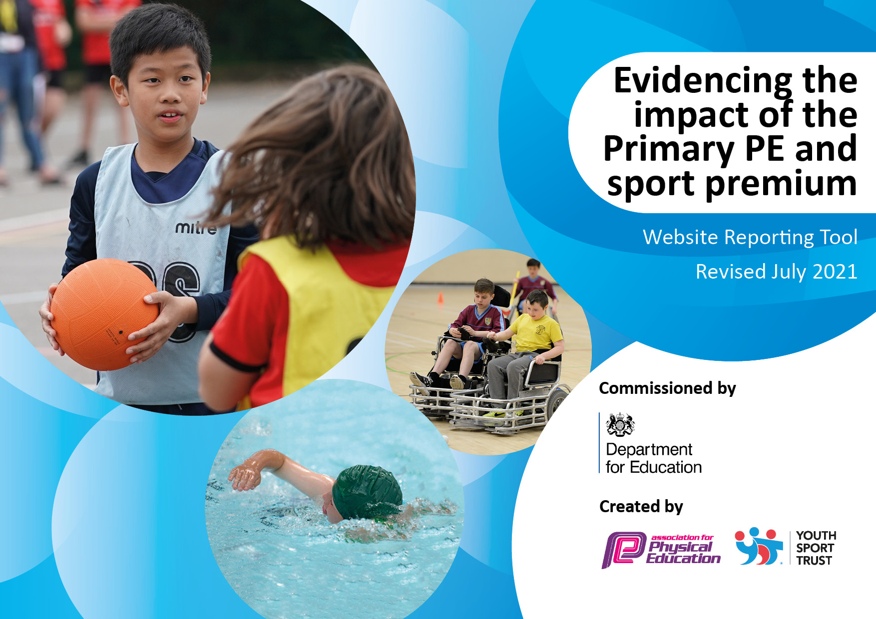
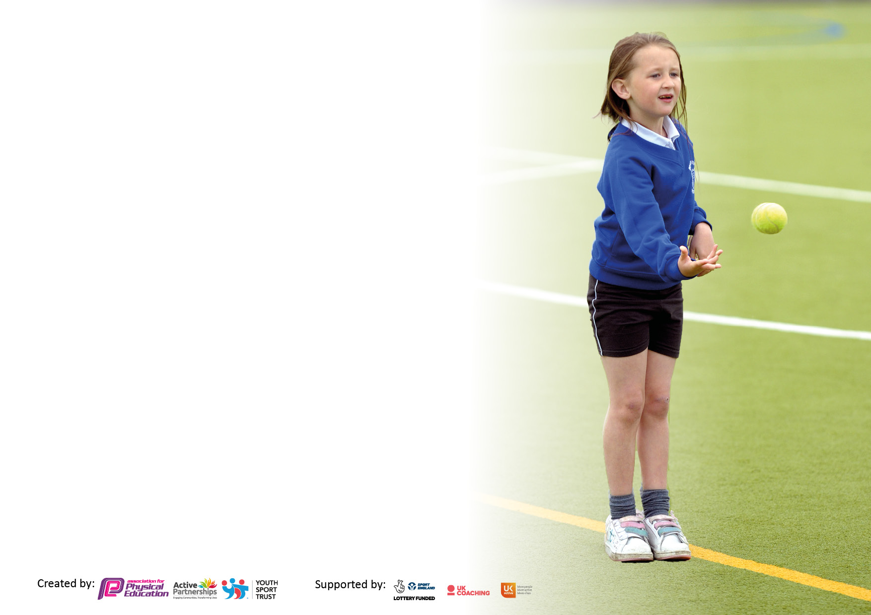

It is important that your grant is used effectively and based on school need. The Education Inspection Framework makes clear there will be a focus on ‘whether leaders and those responsible for governors all understand their respective roles and perform these in a way that enhances the effectiveness of the school’.

Under the Quality of Education Ofsted inspectors consider:
Intent - Curriculum design, coverage and appropriateness
Implementation - Curriculum delivery, Teaching (pedagogy) and Assessment
Impact - Attainment and progress

To assist schools with common transferable language this template has been developed to utilise the same three headings which should make your plans easily transferable between working documents.

Schools must use the funding to make additional and sustainable improvements to the quality of Physical Education, School Sport and Physical Activity (PESSPA) they offer. This means that you should use the Primary PE and sport premium to:

- Develop or add to the PESSPA activities that your school already offer
- Build capacity and capability within the school to ensure that improvements made now will benefit pupils joining the school in future years
- The Primary PE and sport premium should not be used to fund capital spend projects; the school’s budget should fund these.

Pleasevisitgov.ukfortherevisedDfEguidanceincludingthe5keyindicatorsacrosswhichschoolsshoulddemonstrate animprovement.Thisdocumentwillhelpyoutoreviewyourprovisionandtoreportyourspend.DfEencouragesschools to use this template as an effective way of meeting the reporting requirements of the Primary PE and sport premium.

We recommend you start by reflecting on the impact of current provision and reviewing the previous spend.

Schools are required to publish details of how they spend this funding, including any under-spend from 2019/2020, as well as on the impact it has on pupils’ PE and sport participation and attainment. All funding must be spent by 31st July 2022.

We recommend regularly updating the table and publishing it on your website throughout the year. This evidences your ongoing self-evaluation of how you are using the funding to secure maximum, sustainable impact. Final copy must be posted on your website by the end of the academic year and no later than the 31st July 2021. To see an example of how to complete the table please click HERE.

Details with regard to funding
Please complete the table below.

Total amount carried over from 2019/20 | £0
Total amount allocated for 2020/21 | £19,270
How much (if any) do you intend to carry over from this total fund into 2021/22? | £0
Total amount allocated for 2021/22 | £19252
Total amount of funding for 2021/22. To be spent and reported on by 31st July 2022. | £19252
Swimming Data
Please report on your Swimming Data below.

Meeting national curriculum requirements for swimming and water safety.

N.B. Complete this section to your best ability. For example you might have practised safe self-rescue techniques on dry land which you can then transfer to the pool when school swimming restarts.
Due to exceptional circumstances priority should be given to ensuring that pupils can perform safe self rescue even if they do not fully meet the first two requirements of the NC programme of study
What percentage of your current Year 6 cohort swim competently, confidently and proficiently over a distance of at least 25 metres?  N.B. Even though your pupils may swim in another year please report on their attainment on leaving primary school at the end of the summer term 2020.  Please see note above | %
What percentage of your current Year 6 cohort use a range of strokes effectively [for example, front crawl, backstroke and breaststroke]?  Please see note above | %
What percentage of your current Year 6 cohort perform safe self-rescue in different water-based situations? | %
Schools can choose to use the Primary PE and sport premium to provide additional provision for swimming but this must be for activity over and above the national curriculum requirements. Have you used it in this way? | Yes/No

Action Plan and Budget Tracking
Capture your intended annual spend against the 5 key indicators. Clarify the success criteria and evidence of impact that you intend to measure to evaluate for pupils today and for the future.

Academic Year: 2020/21 | Total fund allocated: | Date Updated:
Key indicator 1: The engagement of all pupils in regular physical activity – Chief Medical Officers guidelines recommend that primary school pupils undertake at least 30 minutes of physical activity a day in school |  |  |  | Percentage of total allocation:
 |  |  |  | 47%
Intent | Implementation |  | Impact
Your school focus should be clear what you want the pupils to know and be able to do and about  what they need to learn and to  consolidate through practice: | Make sure your actions to achieve are linked to your intentions: | Funding allocated: | Evidence of impact: what do pupils now know and what can they now do? What has changed?: | Sustainability and suggested next steps:
To get ALL children across the school to be active for an additional 30 minutes per day.  Increased amount of equipment to be used in PE lessons.  Qualified coaches in school one afternoon per week for staff CPD/ team teaching. (LSSP)  LFC foundation one afternoon per week.  Specialist Dance teacher initially for staff who are less confident in the delivery of dance.  Identified target groups will ensure ALL children are receiving at least 30 minutes of activity per school day.  Daily mile | All teachers in implement fiveminute movement breaks between lessons. Purchase “5 a day” resource to help deliver Active Maths Lessons across KS2 and KS1.  Focussing on SEND children to help develop gross motor skills  Sufficient amount of equipment available for the children to be able to access PE lessons and for staff to be able to deliver quality PE lessons.  Coaches to provide quality CPD to aid staff in the teaching of PE.  Teacher provides quality CPD for 1 term Identify target children through PE assessment tracker system.  Implementation of a range of sporting activities for target groups e.g. fun run for girls, fitness is fun to promote physical activity.  All classes to build up to running one mile per day – Commencing spring term. | £380  £1500  £3000  £2200  £2000  Included in equipment funding (See above)  Free Use running track around playground | Children will have increased fitness levels that can be evidenced in weekly bleep tests. By summer term all children will have increased levels of fitness.  By summer the children will be using the equipment correctly and regularly in a range of sports – having full access to PE lessons.  All lesson observations have been to a high standard and any feedback has been implemented. Increased staff confidence.  100% of children seeking opportunities to take part in extra physical activity sessions.  100% of children to build on their fitness week on week. | Staff to continue to timetable movement breaks between lessons to sustain fitness levels.  Take regular inventories and liaise with staff to ensure correct equipment is available to use for PE lessons.  Termly staff questionnaires about equipment needed for lessons. Specialist coaches on hand to advise and team teach to ensure staff are increasingly confident in the delivery of PE lessons.  Specialist dance teacher on hand to advise and team teach to ensure staff are increasingly confident in the delivery of dance lessons.  For targeted children to independently seek out opportunities.  Continue to monitor fitness throughout the year - In the winter fitness can by monitored further by using the weekly bleep test.
Key indicator 2: The profile of PESSPA being raised across the school as a tool for whole school improvement |  |  |  | Percentage of total allocation:
 |  |  |  | 2%
Intent | Implementation |  | Impact
Your school focus should be clear what you want the pupils to know and be able to do and about  what they need to learn and to  consolidate through practice: | Make sure your actions to achieve are linked to your intentions: | Funding allocated: | Evidence of impact: what do pupils now know and what can they now do? What has changed?: | Sustainability and suggested next steps:
Sporting idol to come into St. Michael’s so pupils can aspire to be a sporting hero.  After school sports clubs.  All staff to take responsibility for raising the profile of PE. | Invite local sporting hero to the school and talk about experiences in sport to promote physical activity. Corede Adedoyin (ex pupil ) to talk to children about sports benefits and achieving goals.  3 per week including LFC, dance and dodgeball.  Twitter – for all staff to take a whole school approach to document sporting achievments as well as sporting opportunities available for our children both within school and our community. Displays – to make prominent the children’s achievements within our school and feedback on sporting opportunities and competitions which share our pupil voice. Badge schemes displayed enabling the children to know what they have to do to improve and strive to achieve their personal best.  Weekly class awards medals/certificates given out to celebrate any sporting achievements. | Free  Included in LFC LSSP dance cost.  £100  Medals | Children will be inspired to become more physically active and to achieve their goals.  All children involved in clubs will become more skilful in a smaller groups setting with more precision teaching.  100% of children more engaged  And involved in sport. | Raising the profile of PESSPA is  important therefore another  sporting idol could potentially  come into our school to  promote physical activity.  Encouraging a variety after school clubs will promote further physical activity.  Increased number of  notice boards and  displays around school.  Continue to raise the  profile of PE and school  sport.

Key indicator 3: Increased confidence, knowledge and skills of all staff in teaching PE and sport |  |  |  | Percentage of total allocation:
 |  |  |  | 32%
Intent | Implementation |  | Impact
Your school focus should be clear | Make sure your actions to | Funding | Evidence of impact: what do | Sustainability and suggested
what you want the pupils to know | achieve are linked to your | allocated: | pupils now know and what | next steps:
and be able to do and about | intentions: |  | can they now do? What has
what they need to learn and to |  |  | changed?:
consolidate through practice:
To ensure all staff are growing in confidence every week in the teaching and delivery of PE lessons.  Change PE specialists every term.  Autumn – DANCE  Spring – Athletics  SUMMER – Gaelic football  Update and implement in line with  Ofsted framework, a new progressive  PE curriculum that all staff are  confidence to deliver | Purchased PE scheme GET Set4 PE.  Get specialist to deliver/model and plan and PE lessons.  Identify gaps within the  subject e.g. confidence in  staff teaching PE allowing  for staff (both teachers and  TA’s).  • Co-ordinator providing  support for all teaching and  support staff when  necessary through  workshops, Q&A sessions  and twilight sessions. | £900  £6000  Included  In KMC package | Securing confidence in  staff to help maintain high  standards of teaching in all  who lead and support  within the teaching of PE  Children receiving highly  effective physical  education lessons both  indoor and outdoor PE and  making progress whatever  their level of ability.  • Professional relationships  ensure that all classes have  the best possible PE  experiences and the  continuity of the  programmes enable the  children to be challenged  appropriately.  All staff will be competent in the teaching of dance, athletics, an gaelic football by summer 2021.  Increased confidence levels  of staff in delivering PE  curriculum  A progressive curriculum  for all children in all PE  areas e.g. dance, gym,  games, athletics | Continue to monitor the effectiveness of Get se4 PE.  Lesson observations to observe effectiveness.  Continue to observe lessons to evaluate the effectiveness and quality of teaching.  Staff questionnaire to  identify any areas of the  curriculum which may  still need additional  support.  PE coordinators to seek  out courses for staff  which can further  educate and up-level  staff.  PE coordinators to seek  out courses for staff  which can further  educate and up-level  staff.
Key indicator 4: Broader experience of a range of sports and activities offered to all pupils |  |  |  | Percentage of total allocation:
 |  |  |  | 11%
Intent | Implementation |  | Impact
Your school focus should be clear | Make sure your actions to | Funding | Evidence of impact: what do | Sustainability and suggested
what you want the pupils to know | achieve are linked to your | allocated: | pupils now know and what | next steps:
and be able to do and about | intentions: |  | can they now do? What has
what they need to learn and to |  |  | changed?:
consolidate through practice:
To provide staff with training in OAA.  To organise alternative sports.  To facilitate national/international  sporting events in our local area to  enthuse learning of pupils throughout a wide range of sports (COVID PERMITTING) | Contact external providers LSSP KMC to organise staff training on OAA.  Children in Year 5/6 partake in level 1/2 bikeabilty session lead by  Qualified instructors.  Seeking opportunities for  international events e.g.  netball /rugby games. (COVID PERMITTING)  Broadening the range of  activities offered to the  children to take part in  whether it is to compete  against other schools or  provide a challenge/new  experience. | £2000  Free  Tickets  (£250)  Included in  LSSP package | 100% of staff will be able to deliver OAA lessons independently  All children in year 5/6 will leave school with at either bikeabilty level 1 or 2.  100% of children will be more proficient at confident when bike riding.  The numbers of children  engaging in alternative  sports and competition to  increase.  Children independently  seeking out alternative  sports. | Provide follow up CPD-refresher lessons on the delivery of OAA.  Children can apply skills acquired to an outdoor setting when riding bikes on roads.  Pupils/sports leader’s  questionnaires to advise  staff and PE  coordinators of what  children’s interests to  pursue.

Key indicator 5: Increased participation in competitive sport |  |  |  | Percentage of total allocation:
 |  |  |  | 8%
Intent | Implementation |  | Impact
Your school focus should be clear | Make sure your actions to | Funding | Evidence of impact: what do | Sustainability and suggested
what you want the pupils to know | achieve are linked to your | allocated: | pupils now know and what | next steps:
and be able to do and about | intentions: |  | can they now do? What has
what they need to learn and to |  |  | changed?:
consolidate through practice:
To increase the number of children  participating in competitions. | Purchase LSSP competition  package, allowing our children  to take part in competitions  against other children from  other schools.  Virtual competitions | £1775 LSSP  Package | Increased numbers of  children entered into competitions.  Virtual competitions will increase the number of children taking part in sporting activities. (All children can “try out” for competitions. | Continue to identify  new competitive  opportunities in new  sports for a wide range  of children.  To look at alternative  Virtual sporting events that  capture the imagination  of pupils and link it to  our school sports  programme.

Signed off by
Head Teacher:
Date:
Subject Leader:
Date:
Governor:
Date:

